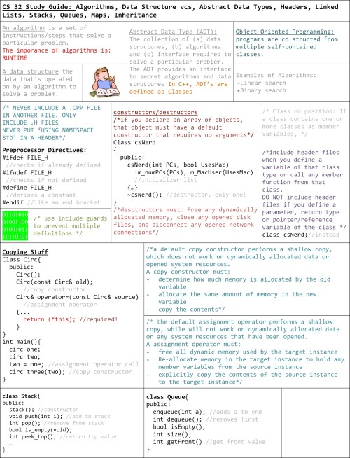

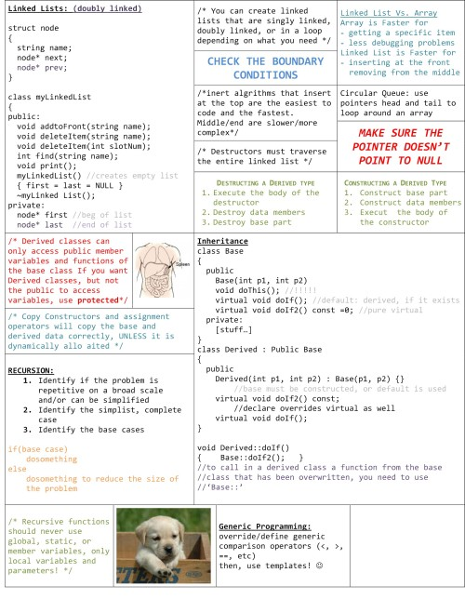

.h

